1. ELASTIC BUCKLING ANALYSIS OF COLD-FORMED STEEL STRUCTURES

Cold-formed steel (CFS) members presents very slender thin-walled open cross-sections, a feature making them highly susceptible to several instability phenomena, namely local/plate (L), distortional (D), and global (G-flexural or flexural-torsional) buckling. Thus, their overall structural response and ultimate strength are affected, to a larger or smaller extent, by these instability phenomena, which explains why they must necessarily be incorporated in CFS specifications.

To examine the elastic buckling behavior of CFS members, analytical models (or closed-form solutions) and numerical methods are available. This chapter emphasis is on numerical solution methods, concentrating on computational tools for elastic buckling analysis of CFS members, although, analytical models also be briefly discussed.

* 1. Analytical formulae or models

The classic beam theory provides explicit expressions for critical loads of global buckling, such as the well-known Euler buckling formula. Thus, global stability is commonly understood as rigid cross-section deformations. Despite its practicality, Euler’s formula is mechanically inaccurate. In fact, compared to the critical loads of global buckling provided by numerical solutions such as the Finite Element Method (FEM) and Finite Strip Method (FSM), the error is exactly equal to the fundamental rigidity difference between beam and plate theory [1]

The classic plate theory provides closed-form solutions to local buckling for a single plate supported along its edges, when it is subjected to direct compression, bending, shear, or a combination of these stresses in its plane. The critical loads take form by seeking a plate-buckling coefficient , a function of plate geometry and boundary conditions for a given loading. These buckling coefficients for various loadings, such as uniform compression, compression and bending, and shear, are summarized in the stability design guide for metal structures. However, these closed-form solutions ignore the interaction of plate elements of the whole cross-section, and may result in excessively conservative solutions.

Analytical formulae for analyzing distortional buckling were also pursued by researchers. For various loading and boundary conditions of C- and Z-section members with arbitrary sloping single-lip stiffeners, Silvestre and Camotim [2], [3] proposed a generalized beam theory (GBT) based on fully analytical formulae to assess distortional critical buckling length and stress. The novelty of these formulae is the utilization of the governing differential equations of GBT, which is able to incorporate folded-plate theory for high accuracy.

Empirical formulae for distortional buckling stress were also proposed using available data obtained from the above analytical models, or numerical solutions such as GBT and FSM using genetic programming [4] or neural networks [5]. Though lacking a mechanical basis, these empirical formulae did have the advantage of simplicity in predicting distortional buckling loads.

* 1. Numerical solution methods for elastic buckling analysis

To examine the elastic buckling behavior of CFS members, the main numerical solution methods are the Finite Element Method (FEM), Finite Strip Method (FSM), Generalized Beam Theory (GBT), and more recently the constrained FSM (cFSM).

* + 1. Finite Element Method (FEM)

Due to the thin nature of a CFS cross-section, the application of FEM in stability analysis of CFS members is commonly built from the shell elements so the cross-section deformation can be captured. Given the many advances in computation, shell FEM has become popular in analyzing CFS structures for elastic (eigen) buckling analysis. Its unique applicability to handle complex geometry and boundary conditions makes it a natural choice in many situations. Moreover, its applicability in nonlinear collapse analysis by taking into consideration material and geometrical nonlinearities proves to be even more powerful for stability analysis of CFS [1].

Shell FEM requires a user to generate a full three-dimension shell model, then run an eigen buckling analysis to find buckling loads (eigenvalues) and associated buckled mode shapes. Although the formulation of the stiffness matrices may use different plate theories (eg, KirchhoffeLove theory versus MindlineReissner theory), a similar eigenvalue problem associated with elastic buckling on a perfect structure considering only geometric nonlinearity may be defined as

where is the conventional elastic stiffness matrix, is the geometric stiffness matrix, is the eigenvalue (load factor is compression positive), and is the eigenmode (buckling mode) vector.

Computation modeling of CFS is always an intricate task with a variety of parameters that may influence the analysis. In elastic buckling analysis, three more influential aspects are boundary conditions, element selection, and mesh.

Boundary conditions necessitate careful treatment in computational modeling of CFS structures. They have an excessive impact on elastic buckling analysis (and on collapse analysis as well); in particular, the issue of longitudinal warping restraint at the member ends may commonly be overlooked. In addition, it is worth noting that the real boundary conditions in CFS systems are usually far more complex than those existing in laboratory experiments, and are never as clean as in the computational models.The election of a shell element appropriate for the modeling at hand is a broad topic. The issues of importance may include order of the element (ie, linear, quadratic, etc.), implementation of Mindlin or Kirchhoff strain assumptions, and integration scheme. Depending on the choice of shell elements, the impact of mesh sensitivity  
varies.

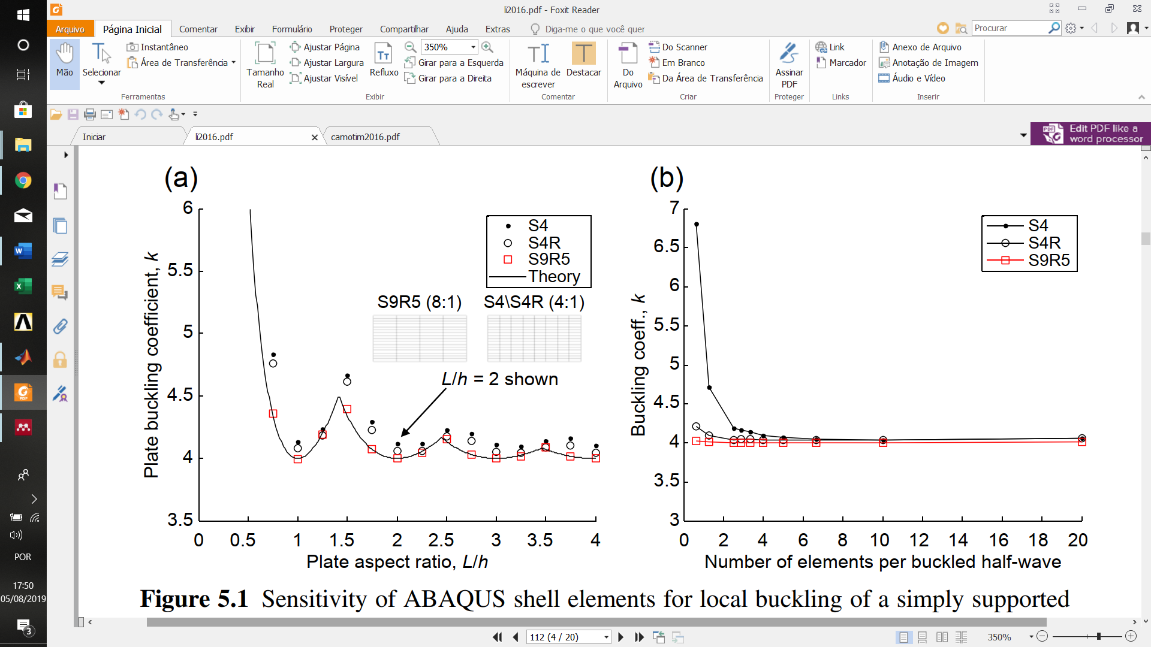

Figure 1: Sensitivity of ABAQUS shell elements for local buckling of a simply supported plate in compression: (a) varying physical plate length; (b) varying number of elements along the length [6]

Figure 1 illustrates the Sensitivity of using elementd S4, S4S, and S9R5, within the well-known general-purpose finite element method package ABAQUS [7].As shown in Figure 1 (a), the quadratic element (S9R5) allows as little as one element per buckling half-wave ( Figure 1 (b)) to provide excellent and robust solutions in comparing with (Kirchhoff) thin plate theory. When fewer than five elements are used per buckled half-wave, the linear element (S4) locks, and while the S4R, which includes a reduced integration scheme to lessen the impact of shear locking, performs reasonably well, it is still outperformed by the quadratic S9R5 even when the number of nodes is the same.

Given the complex buckling modes of CFS members (ie, local, global, distortional), correct identification and classification of these buckling modes and accurate calculation of the associated elastic critical loads (or moments) are crucial in predicting the ultimate strength of a CFS member. While shell FEM can handle arbitrary cross-sections, boundary conditions, and loads, it is limited by the difficulties of modeling and identifying the characteristic buckling modes (local distortional, global), because shell FEM itself provides no means of modal identification, and instead requires a laborious and subjective procedure employing visual investigation to classify the buckling modes in elastic buckling analysis.

* + 1. Finite Strip Method (FSM)

The FSM is a variant of the FEM. For its application to thin-walled structures, instead of a finite element discretization (Figure 2 (a)), a thin-walled cross-section is discretized into a series of longitudinal strips (or elements) (Figure 2 (b)). Shape functions in the transverse and longitudinal directions are selected to represent the displacement field. Then, similar to FEM, an eigenvalue problem for elastic buckling analysis, similar to Eq. with less degree of freedoms, can be formulated using different plate theories.

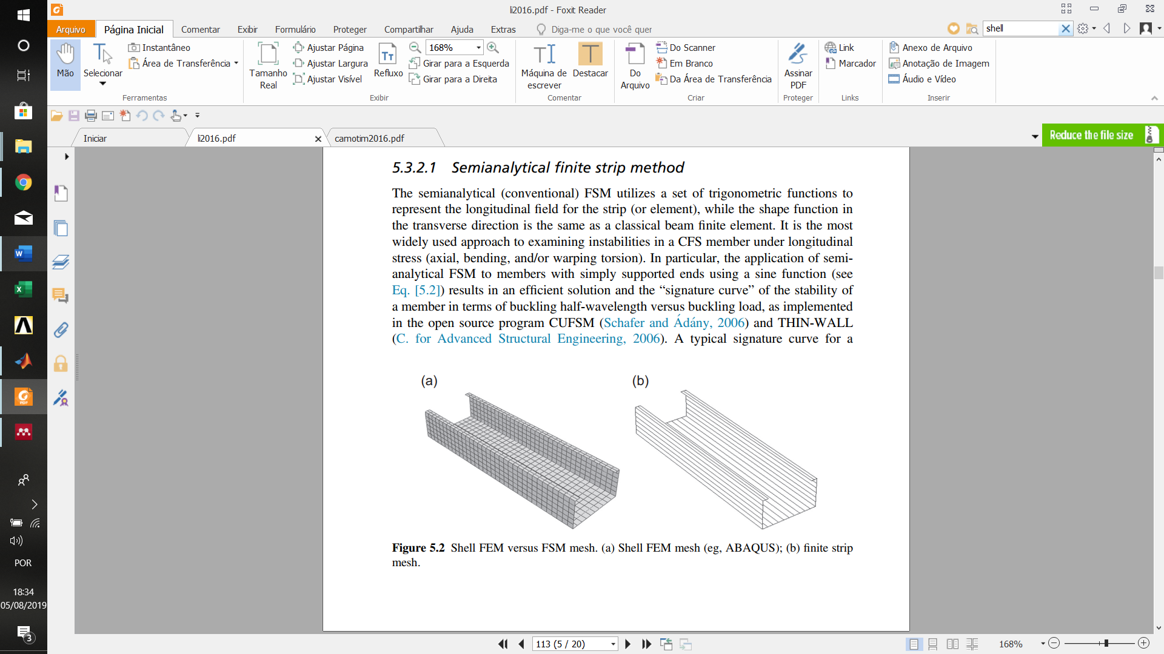

Figure 2: Shell FEM versus FSM mesh. (a) Shell FEM mesh;(b) finite strip mesh

The conventional FSM utilizes a set of trigonometric functions to represent the longitudinal field for the strip, while the shape function in the transverse direction is the same as a classical beam finite element. It is the most widely used approach to examining instabilities in a CFS member under longitudinal stress (axial, bending, and/or warping torsion). In particular, the application of semi-analytical FSM to members with simply supported ends using a sine function results in an efficient solution and the signature curve of the stability of a member in terms of buckling half-wavelength versus buckling load, as implemented in the open source program CUFSM [8].

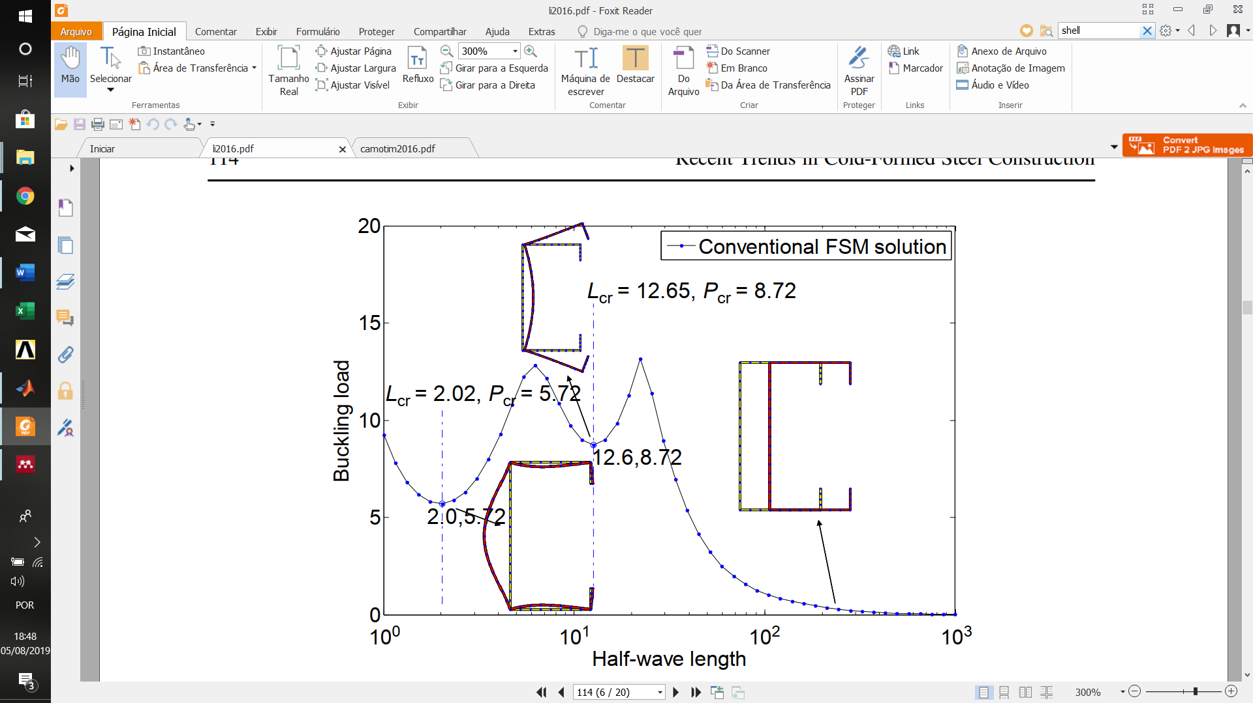

Figure 3: A typical signature curve of an FSM solution [8]

Minima in the signature curve shown in Figure 3 indicate the lowest critical load at which a particular buckling mode occurs. Traditionally, local buckling occurs at the first minimum, distortional buckling at the second, and global buckling is identified in the descending branch of the curve at a longer half-wavelength equal to the global unbraced length of the member. Note that for a physical length, the identified lowest buckling mode will repeat itself along the physical length at or near the minimal half-wavelength.

* + 1. Constrained Finite Strip Method (cFSM)

The cFSM is derived from semi-analytical FSM by separating the original displacement field of FSM into four buckling mode categories: global (G), distortional (D), local (L), and shear and transverse (ST) extension. The separation is made possible by enforcing a set of mechanical assumptions, as shown in Table 1. Similar deformation modes can also be defined, as shown in Figure 5.

Using the mechanical criteria, a set of constraint matrices, , , , and , can be formulated for the four mode categories. Thus, a key relationship of the original and reduced displacement fields can be expressed as:

where is the general displacement field, is the reduced displacement field that  
matches buckling mode , is the constraint matrix for buckling mode , and M  
refers to the modal space (, , , , or any combination thereof)

An extension of cFSM to general end boundary conditions [9] was implemented in CUFSM [6]. Ádány and Schafer [10] also enabled cFSM to handle closed cross-sections by generalizing the modes through implementation of the criteria regardless of cross-section topology.

Modal decomposition is one of the main applications of cFSM, and provides a powerful means for examining any individual or combined modes of interest. Instead of solving the generalized eigenvalue problem in FSM, modal decomposition solves a reduced eigenvalue problem by introducing the constraint matrix to the original eigenvalue problem of FSM. The constrained eigenvalue problem corresponding to modes is expressed as

where is a diagonal matrix containing the eigenvalues for the given modes and is the matrix corresponding buckling modes in its columns. Also, and may be defined as the elastic and geometric stiffness matrix of the cFSM problem, respectively.

Table 1: Mechanical criteria of mode definition

|  |  |  |  |  |
| --- | --- | --- | --- | --- |
| **Mechanical criteria** | **G** | **D** | **L** | **ST** |
| Valsov’s hypothesis: | Yes | Yes | Yes | No |
| Longitudinal warping: | Yes | Yes | No | - |
| Undistorted section: | Yes | No | - | - |

Modal identification is another main application of cFSM. The combined , , , and subspaces, as defined in the constraint matrices, provide a complete alternative basis to the original FSM displacement fields and represent a transformation of the solution from the original nodal degrees of freedom to a basis that separates , , , and modes. This basis may be used to evaluate the contribution of the different deformation modes (, , , and ) to any general deformed shape after appropriate normalization. This procedure is known as modal identification. Any displaced shape or buckling mode, , can be transformed into the basis spanned by the deformation classes through:

where , , , and are column vectors that include the contribution  
coefficients for each vector inside each deformation class. Then the participation () of space in a general deformation () given the contribution coefficients is calculated using the absolute sum.

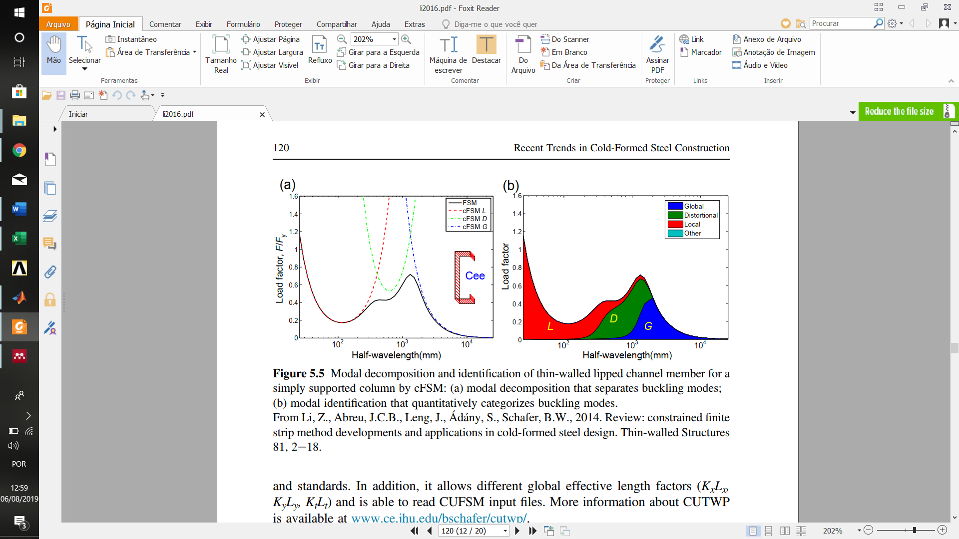

Figure 4: Modal decomposition and identification of thin-walled lipped channel member for a simply supported column by cFSM: (a) modal decomposition that separates buckling modes; (b) modal identification that quantitatively categorizes buckling modes [11]

Figure 4 illustrates modal decomposition and identification for the simply supported end boundary conditions of a C-column. The columns of may be considered as a set of base vectors in this space of mode and transformation inside space is also possible, thus the base vectors defined by are not unique. The modal decomposition and identification solutions may be affected by different transformations.

* + 1. Generalized Beam Theory (GBT)

GBT is a beam theory that incorporates the global motions of the cross-section and distortional and local deformations, and is applicable to prismatic members. GBT can provide elastic buckling analysis for CFS members under a variety of loading and boundary conditions. Beside the general solutions in terms of elastic buckling loads and shapes that other methods (eg, FEM and FSM) are able to produce, it is one of only two methods (the other is cFSM, discussed later) that can provide separation and identification of the buckling modes. In addition, work by Gonçalves and Camotim [12] enabled GBT to perform nonlinear analysis, including geometric  
and material nonlinearity. Related works on GBT can be found in Bebiano et al. [13], Abambres et al.[14]–[16], Basaglia et al. [17], and Silvestre and Camotim [18].

GBT transforms degrees of freedom from nodal to modal, which can be viewed as an extension of Vlasov’s classical bar theory. In particular, by integrating the cross-section deformations, GBT has a foundation in folded-plate theory and uses a unique cross-section analysis procedure to unveil the deformation modes in displacement fields.

Through integration of displacement fields along the cross-section midline coordinate in GBT formulation, the cross-section analysis results in four basic mechanical matrices, , , , and , that are the generalized section properties which depend only on the cross-section geometry. Matrix is related to the warping stiffness of the cross-section, and matrix associates with the transverse bending stiffness of the cross-section. Matrix ties to the twisting stiffness, while matrix is second order section properties relating the cross-section deformations to stress distributions. With these fully populated generalized matrices, a sequence of three eigenvalue problems can be solved to extract the fundamental modes of local, distortional, and global buckling.

Besides the fundamental modes (some are illustrated in Figure 5), the byproduct of this sequence is that all matrices (, , , and ) now possess a modal nature. Matrices and have a diagonal form, and are partially diagonalized.

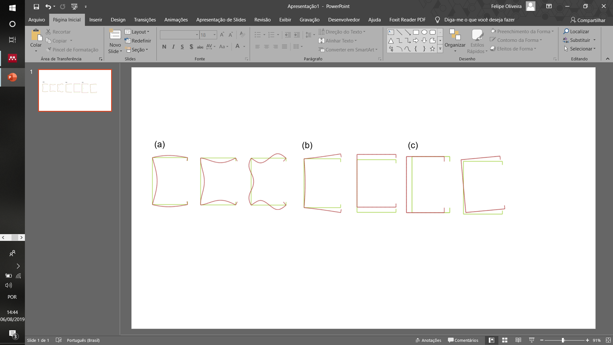

Figure 5: In-plane shapes of the seven most relevant deformation modes. (a) L mode ;(b) D mode ;(c) G mode

After performing the cross-section analysis, the linear elastic buckling analysis of a  
thin-walled member with the appropriate end support conditions can be obtained by solving a governing differential equation, where denotes certain modes), expressed in terms of the modal amplitude functions as

Differential Eq. can be solved analytically using a similar sine longitudinal function to FSM if the end boundary conditions are simply supported.

* 1. Open source programs and other software packages
     1. GBTUL

GBTUL, short for GBT at the University of Lisbon, is a free software program that can  
provide elastic buckling and vibration analyses of prismatic thin-walled members. The  
kernel incorporates the latest formulations of GBT. GBTUL took advantage of GBT’s  
modal features to provide information and visualization of member deformation  
modes. With the tool, it is possible to select desired deformation modes in the analysis  
.It is also possible to analyze members made of one or several isotropic or orthotropic materials, and under various common support conditions (eg, simple supports, fixed supports, or free ends). In the buckling analyses, the user is able to specify any combination of arbitrary axial force, bending moment, and bimoment diagrams. GBTUL contains a user-friendly and intuitive graphical interface with a small number of commands and providing high-quality two- and three-dimensional outputs [13].

* + 1. CUFSM

CUFSM is a direct implementation of semi-analytical FSM to provide elastic buckling analysis for thin-walled cross-section members. New extensions over the years have enabled it to perform analysis on general end boundary conditions. More importantly, cFSM implemented in CUFSM gives it a modal feature similar to GBT, thus modal decomposition to study individual mode or mode class, and mode identification by categorizing the general mode into the four fundamental classes, are available in CUFSM. In the analysis, the user can specify any combination of arbitrary axial force, bending moment, and bimoment. CUFSM provides an easy-to-use interface and has been successfully used by researchers, educators, students, and practicing engineers. While CUFSM is most commonly used for analyzing thin-walled CFS members, it has also been used for a large variety of other materials and applications [10].

* + 1. FEM packages

The above tools for elastic buckling analysis of CFS are free software that was  
mainly developed by researchers in the structural stability community, but several  
general-purpose commercial finite element software packages can be used for elastic  
buckling analysis. The principal FEM packages used for CFS analysis are ABAQUS FEA [7] and ANSYS FEA[19].

References

[1] Z. Li, “Advanced computational tools for elastic buckling analysis of cold-formed steel structures”, *Recent Trends Cold-Formed Steel Constr.*, p. 109–128, 2016.

[2] N. Silvestre e D. Camotim, “Distortional buckling formulae for cold-formed steel C and Z-section members: Part I - Derivation”, *Thin-Walled Struct.*, 2004.

[3] N. Silvestre e D. Camotim, “Distortional buckling formulae for cold-formed steel C-and Z-section members: Part II - Validation and application”, *Thin-Walled Struct.*, 2004.

[4] M. Pala, “Genetic programming-based formulation for distortional buckling stress of cold-formed steel members”, *J. Constr. Steel Res.*, 2008.

[5] M. Pala, “A new formulation for distortional buckling stress in cold-formed steel members”, *J. Constr. Steel Res.*, 2006.

[6] B. W. Schafer, Z. Li, e C. D. Moen, “Computational modeling of cold-formed steel”, *Thin-Walled Struct.*, 2010.

[7] Dassault Systèmes Simulia, A. . Fallis, e D. Techniques, “ABAQUS documentation”, *Abaqus 6.12*, 2013.

[8] B. W. Schafer e S. Ádány, “Buckling analysis of cold-formed steel members using CUFSM: Conventional and constrained finite strip methods”, in *Eighteenth International Specialty Conference on Cold-Formed Steel Structures: Recent Research and Developments in Cold-Formed Steel Design and Construction*, 2006.

[9] Z. Li, S. Ádány, e B. W. Schafer, “Modal identification for shell finite element models of thin-walled members in nonlinear collapse analysis”, *Thin-Walled Struct.*, vol. 67, p. 15–24, 2013.

[10] S. Ádány e B. W. Schafer, “Generalized constrained finite strip method for thin-walled members with arbitrary cross-section: Primary modes”, *Thin-Walled Struct.*, 2014.

[11] Z. Li, J. C. Batista Abreu, J. Leng, S. Ádány, e B. W. Schafer, “Review: Constrained finite strip method developments and applications in cold-formed steel design”, *Thin-Walled Structures*. 2014.

[12] R. Gonçalves e D. Camotim, “Geometrically non-linear generalised beam theory for elastoplastic thin-walled metal members”, *Thin-Walled Struct.*, 2012.

[13] R. Bebiano, D. Camotim, e R. Gonçalves, “GBTUL 2.0 − A second-generation code for the GBT-based buckling and vibration analysis of thin-walled members”, *Thin-Walled Struct.*, 2018.

[14] M. Abambres, D. Camotim, e N. Silvestre, “Physically non-linear GBT analysis of thin-walled members”, *Comput. Struct.*, 2013.

[15] M. Abambres, D. Camotim, e N. Silvestre, “GBT-based elastic-plastic post-buckling analysis of stainless steel thin-walled members”, *Thin-Walled Struct.*, 2014.

[16] M. Abambres, D. Camotim, N. Silvestre, e K. J. R. Rasmussen, “GBT-based structural analysis of elastic-plastic thin-walled members”, *Comput. Struct.*, 2014.

[17] D. Camotim, C. Basaglia, e N. Silvestre, “GBT buckling analysis of thin-walled steel frames: A state-of-the-art report”, *Thin-Walled Struct.*, 2010.

[18] N. SILVESTRE e D. CAMOTIM, “NONLINEAR GENERALIZED BEAM THEORY FOR COLD-FORMED STEEL MEMBERS”, *Int. J. Struct. Stab. Dyn.*, 2003.

[19] ANSYS, “ANSYS Mechanical APDL Theory Reference”, *ANSYS Inc*, 2013.